Part 1: Installing Magento 2 in my Local Machine:1.Installed XAMPP

2.Created magento named Database in phpmyadmin

3.Download and extracted magento2 in a demoWebsite named folder in htdocs of XAMpp

4.Installed and setup magento 2

2: Challenges I faced:

1.A lot of php extensions were disabled in php.

2.My frontend page and admin page was broken

3:Solution

1.I enabled them in php.ini file

2.Changed the pathdirectories in validation.php file use replace(/,\\) as i am usig windows 10

3.changed the valid function too in validation.php

4.I had to increase the memory limit of php to 2048 M for faster loading of admin panel.

Part 2: Made a category and products:

Adding Category: Named FootWear

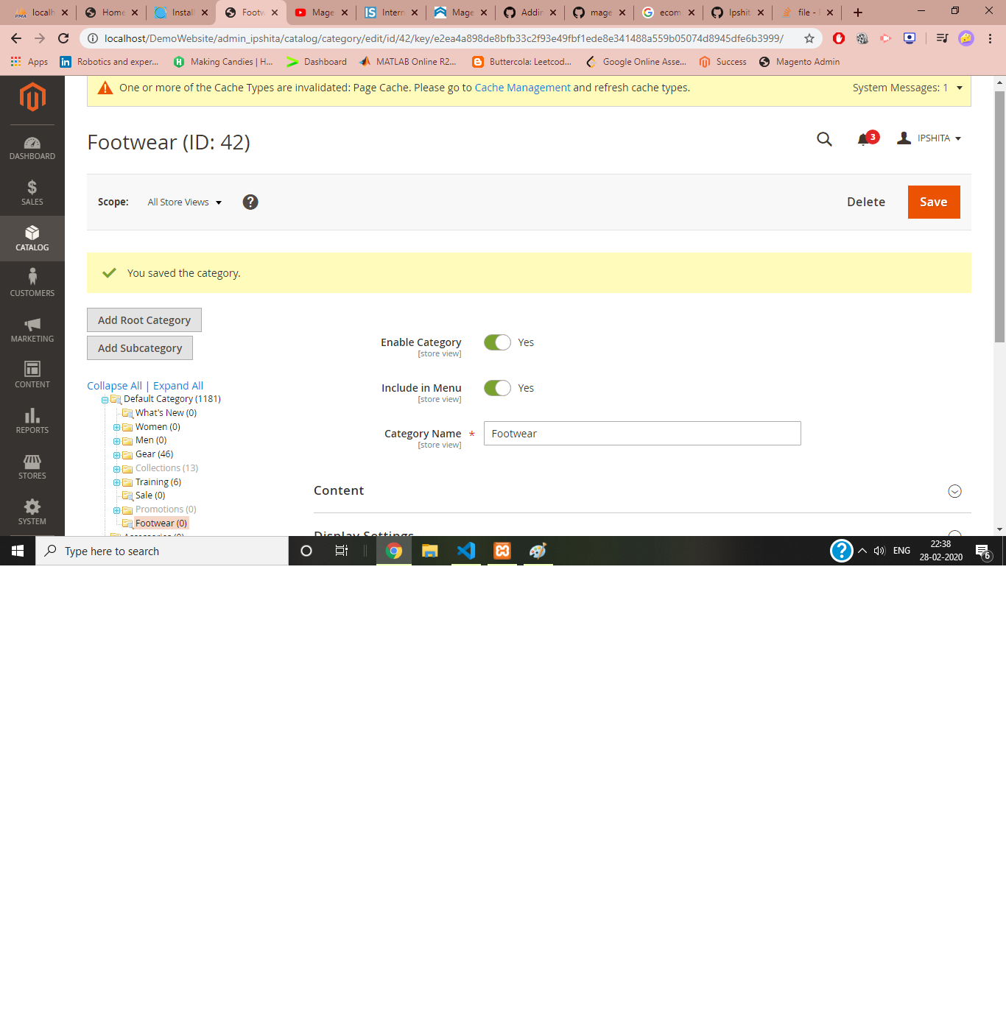

Added Products:

1.PRODUCT 1:Acupressure Slipper

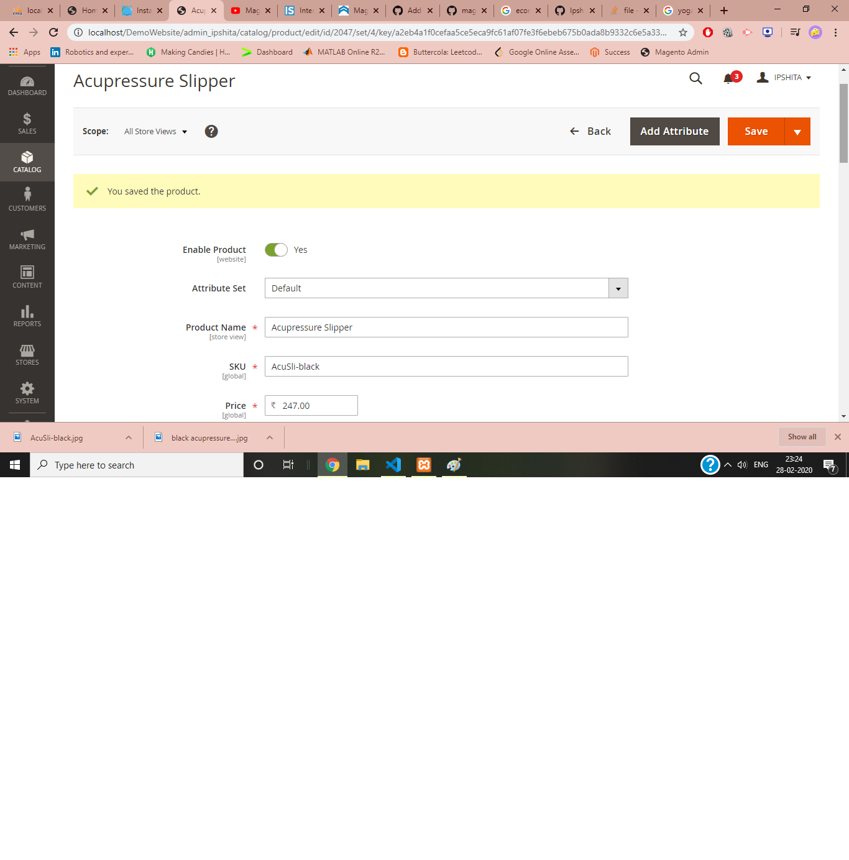

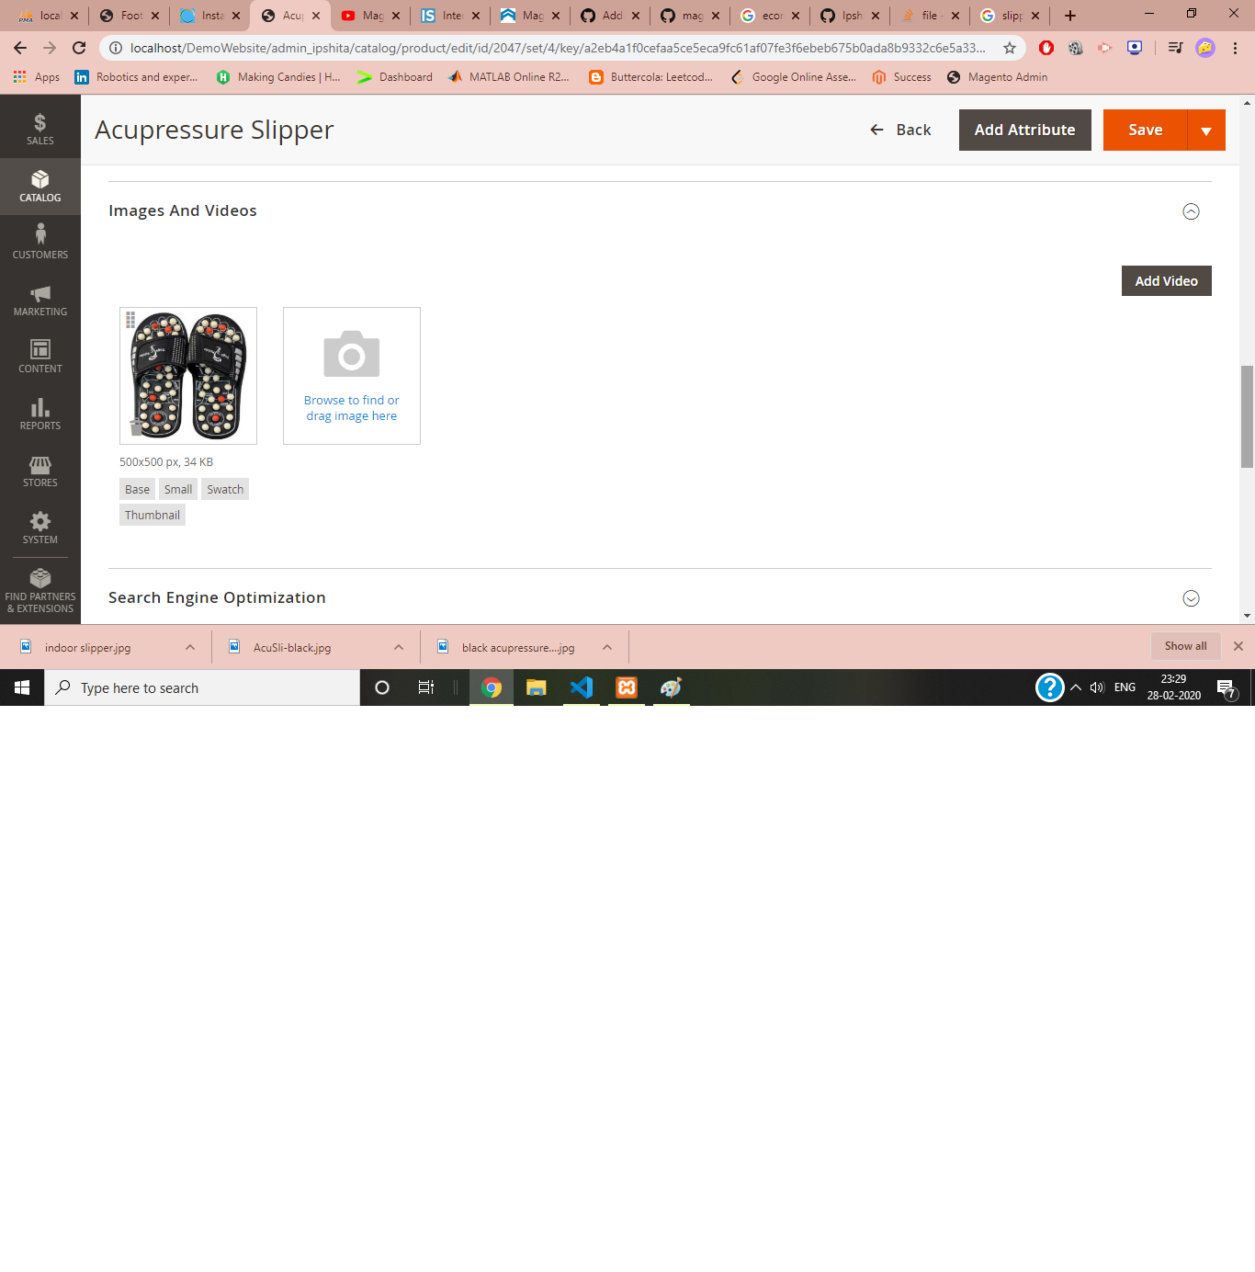

PRODUCT 2: Comfy indoor Slipper:

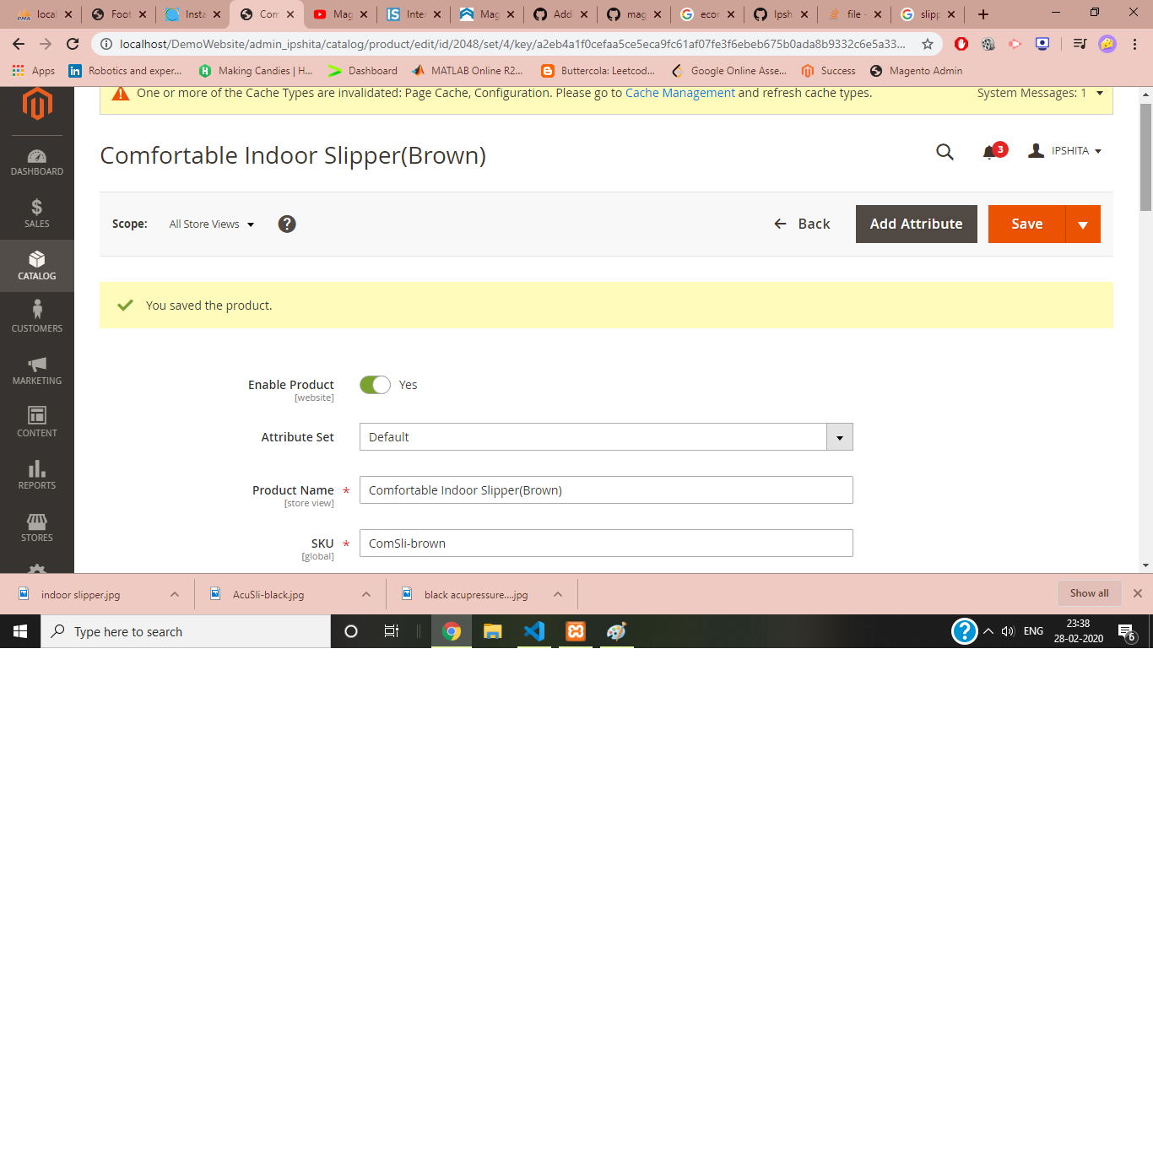

FINAL CATEGORY FRONTEND:

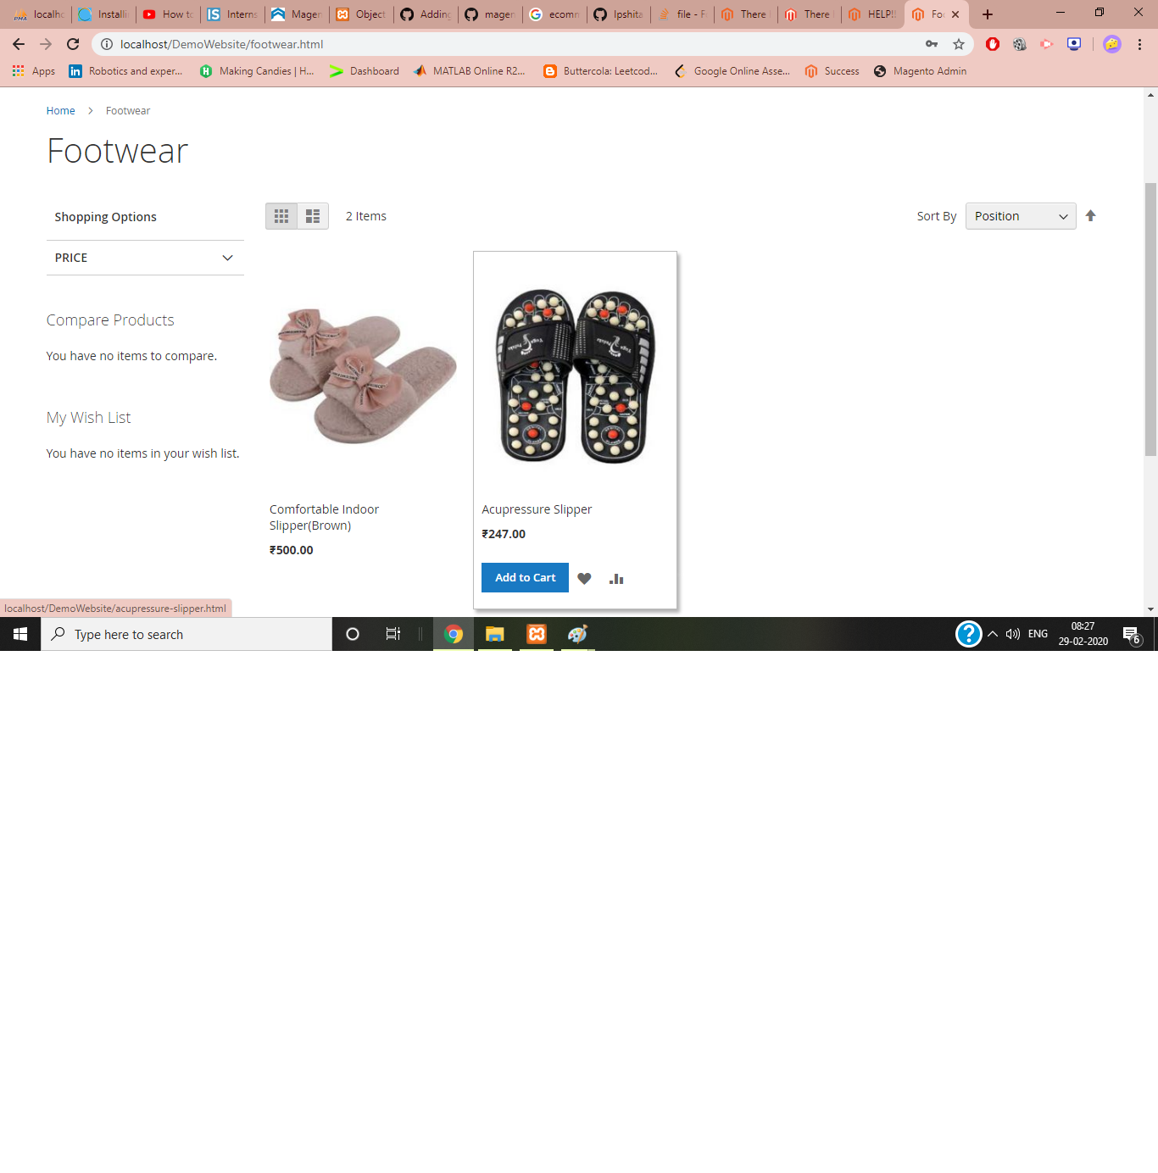

STEP 3: Made 2 modules:

1.Hello World Module(Assignment_HelloModule) and HelloWorld in footer module(Ipshita_HelloWorld)

Step1: made app/code/Assignment/Hellomodule.

Step2.Add etc folder in hellomodule and added module,xml

Step 3.added registration.php on HelloModule

Step 4: Added Controller in HelloModule and in that added index/index.php that has required code in xml

Step 5:Added routes.xml in app/code/Ipshita/HelloWorld/etc/frontend

Step 6: in cmd php bin/magento setup:upgrade

php bin/magento cache:clean

Screenshots: Helloworld module

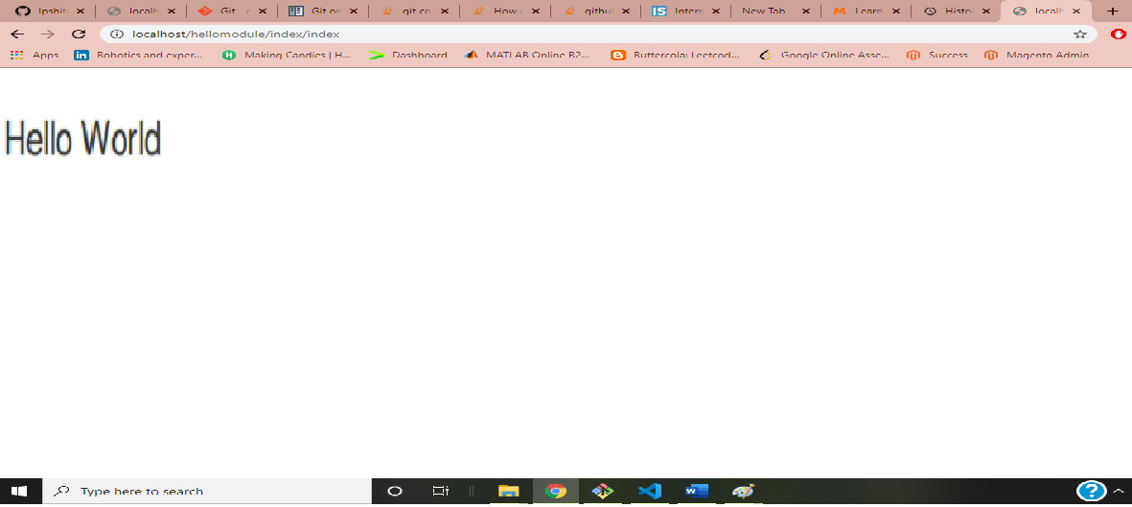

Helloworld in footer:

